Experiment 8 **7 SEGMENT DISPLAY USING 8051 USING KEIL AND PROTEUS**

**AIM:**

Write an assembly language program for 7 Segment Display Using 8051 using Keil and Proteus

**SOFTWARE REQUIRED:**

* Keil software 5.
* Proteus 8 software.

**KEIL PROCEDURE:**

1. Open the software, Click on project and open new version project.

2. Create a new project file

3. Enter AT89C51

4. Click NO

5. Click [Ctrl +N] and Type the code

6. Open project and click Build target

7. Open Build target and open source file and ADD, CLOSE

8. Click build target

9. Next debug start and stop

10. Open peripherals and select port 2

11. Now run the program in Debug

12. Open project and click optional properties and in that give output as hex file.

13.Create Hex file

**PROTEUS SOFTWARE:**

* Open proteus by clicking run as administrator.
* Open new project and enter the file name.
* Click next, next, next and finish.
* Click P symbol and search keyword and place the required components

The components required are:

* AT89C51
* 7 Segment Anode

* Connecting pin number 21 to the first end of the 7 segment
* Likewise, connect pin 22, 23, 24, 25, 26, 27 & 28 to the ends of the 7 Segment
* Select the hex file
* Start the simulation process

**PROGRAM:**

ORG 000H

UP:MOV P2,#0C0H

ACALL DELAY

MOV P2,#0F9H

ACALL DELAY

MOV P2,#0A4H

ACALL DELAY

MOV P2,#0B0H

ACALL DELAY

MOV P2,#99H

ACALL DELAY

MOV P2,#92H

ACALL DELAY

MOV P2,#82H

ACALL DELAY

MOV P2,#0F8H

ACALL DELAY

MOV P2, #80H

ACALL DELAY

MOV P2,#90H

ACALL DELAY

DELAY: MOV R5,#10

H1:MOV R4,#180

H2:MOV R3,#255

H3:DJNZ R3,H3

DJNZ R4,H2

DJNZ R5,H1

RET

END

**CIRCUIT DIAGRAM:**

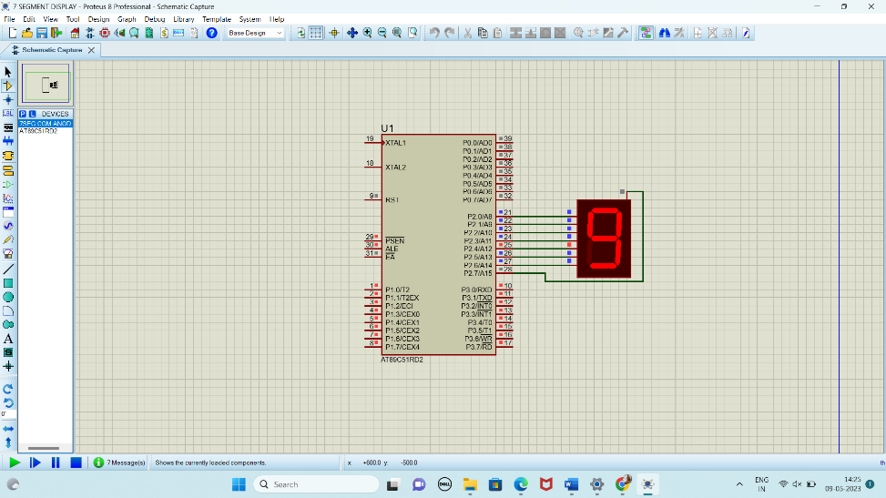

**RESULT:**

Thus the program has been successfully verified and executed.